**Introduction to Data Analytics**

**Lab report #01**



Fall 2022

CSE-408L Data Analytics lab

Submitted by: **Ashfaq Ahmad**

Registration No: **19PWCSE1795**

Class Section: **B**

“On my honor, as student of University of Engineering and Technology, I have neither given nor received unauthorized assistance on this academic work.”

Student Signature: ______________

Submitted to:

**Eng: Faizullah**

**Nov** 10, 2022

**Department of Computer Systems Engineering**

**University of Engineering and Technology, Peshawar**

**Task:** Perform the following:

1. Import the numpy package under the name np
2. Create a vector with values ranging from 10 to 49
3. Reverse a vector (first element becomes last)
4. Create a 3x3 matrix with values ranging from 0 to 8
5. Find indices of non-zero elements from [1,2,0,0,4,0]
6. Create a 3x3 identity matrix
7. Create a 3x3x3 array with random values
8. Create a 10x10 array with random values and find the minimum and maximum values
9. Create a random vector of size 30 and find the mean value

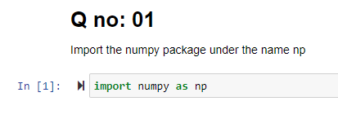

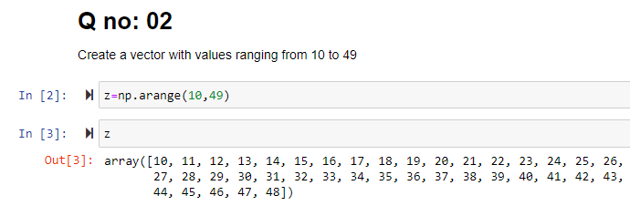

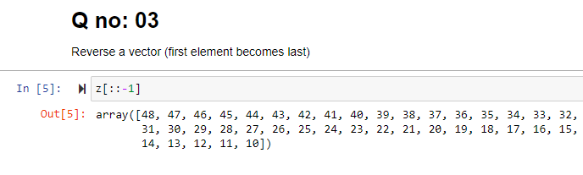

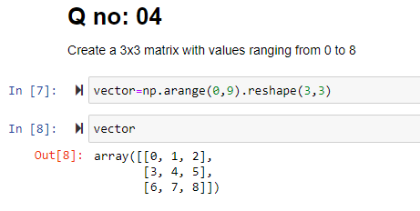

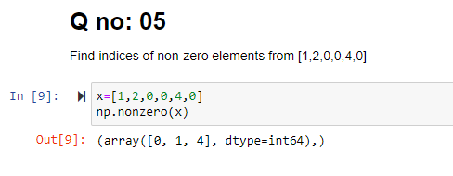

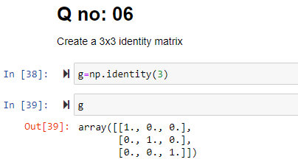

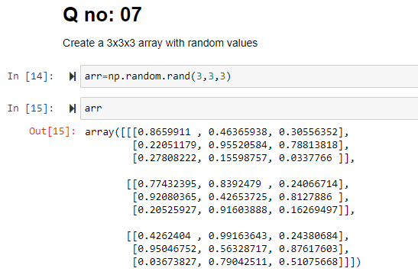

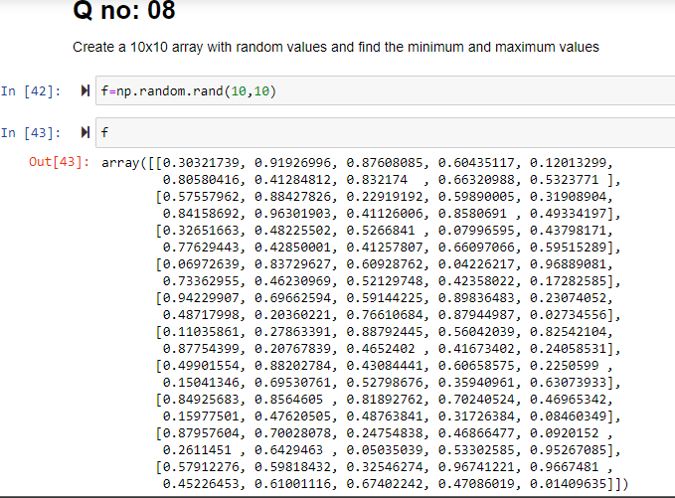

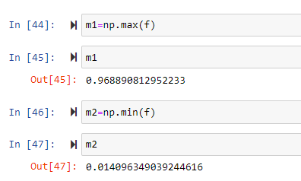

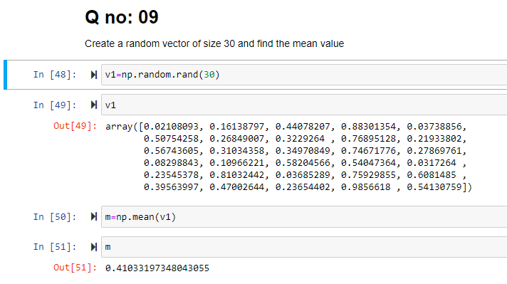

**The End**